

VistA Blood Establishment Computer Software (VBECS) 2.0.0

Installation Guide

May 2014

Department of Veterans Affairs
Product Development

This page intentionally left blank.

Revision History
Date | Revision | Description | Author
05-02-13 | 1.0 | Initial version | BBM team
11-26-13 | 2.0 | Install VBECS Binaries and Services for the Test Environment section: Revised Steps 3, 4, 5, 6 and 11.  Install VBECS Binaries and Services for the Production Environment section: Revised Step 5.  Installing VBECS 2.0.0 Binaries and services section – Change “services” to “Services” in heading.  Global – Change “2.0.0.2” to “2.0.0.3” in document text and screenshots.  Added a reference to the VBECS 2.0.0 Installation Process Diagram.  Installing VBECS 2.0.0 Binaries and Services for the Test Environment section, Step 10 and Installing VBECS 2.0.0 Binaries and Services for the Production Environment section, Step 4: changes “running” word to “listed”. | BBM team
5/27/14 | 3.0 | Globally changed “November 2013” to “May 2014”.  Added that a VBECS team member using their NMEA account must run the installation package.  Added a step to the prod section to change the prod services to run under the “aac.dva.domain\VAAACVBESVCPRD” instead of the initially installed account “aac.dva.domain\VAAACVBESVCPPD”. | BBM team

This page intentionally left blank.

Table of Contents

Revision History 3
Introduction 7
Prerequisites 7
Installing VBECS 2.0.0 Binaries and Services 9
1 Install VBECS Binaries and Services for the Test Environment 9
2 Install VBECS Binaries and Services for the Production Environment 13

This page intentionally left blank.

Introduction
This guide details the process of installing VBECS 2.0.0 binaries on the application server. See the VBECS 2.0.0 Installation Process Diagram located in VSS Doc/VBECS Design and Device Records/VBECS 2.0.0 Project Documents/Packaging, Labeling, and User Documentation Specifications/Installation Guides/Reviewed for an overview of the entire installation process.

Prerequisites
The following must be met before executing this guide:
- VBECS 2.0.0 Template Creation Guide was executed on the target server
- VBECS 2.0.0 was never previously installed on the target server
- VBECS 2.0.0 Installation package was prepared
This page intentionally left blank.

Installing VBECS 2.0.0 Binaries and Services
These instructions detail the process for installing VBECS binaries and services on the application server. There are separate instructions for the test and production environments.

Install VBECS Binaries and Services for the Test Environment
- Using your NMEA account and eToken USB device, open a Remote Desktop Connection to the target application server.
- Open Windows Explorer and navigate to the following path: \\server123\VBECSBuilds (Figure 1). If this link does not work navigate to IPADDRESS \VBECSBuilds.
Figure 1: Example of VBECSBuilds Directory Contents
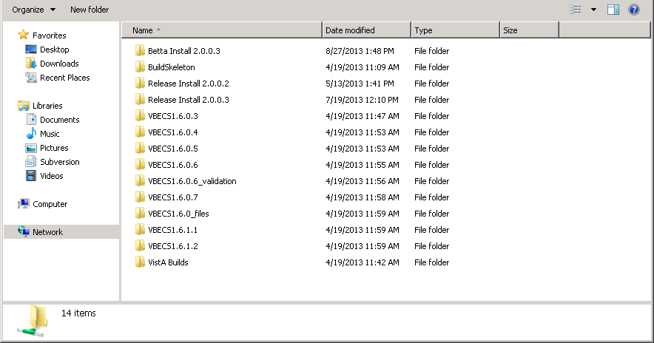
- Make sure that the C:\Temp folder does not contain old installation packages. It is recommended to clean up the temp folder.
- Contact the Lead Developer to verify that the size and contents of the Install Package are correct and that it was not altered.
- Copy the Release Install <build> directory into the C:\Temp folder. Where <build> represents a build number (e.g., 2.0.0.3).
- Open a command prompt window (Figure 2) and type:
cd “c:\temp\Release Install <build>” and press Enter.
Figure 2: Example of Command Prompt Screen
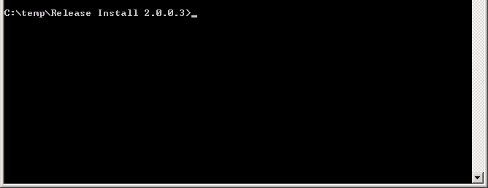
- In the command prompt window, type patch test install and press Enter.
- Verify that after the installation is complete, BUILD SUCCEEDED is displayed in the command prompt window (Figure 3).
Figure 3: Example of Successful Installation
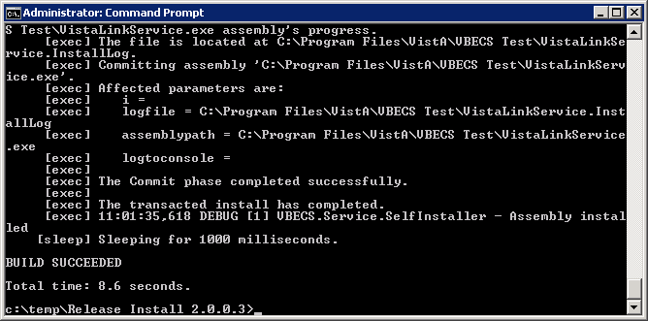
- Using Windows Explorer, navigate to c:\Program Files\VistA and verify that the VBECS Test directory exists. Open VBECS Test directory and confirm that it contains VBECS binaries (Figure 4).
Figure 4: Example of c:\Program Files\VistA\VBECS Test Directory Contents after Successful Installation of VBECS Test Binaries
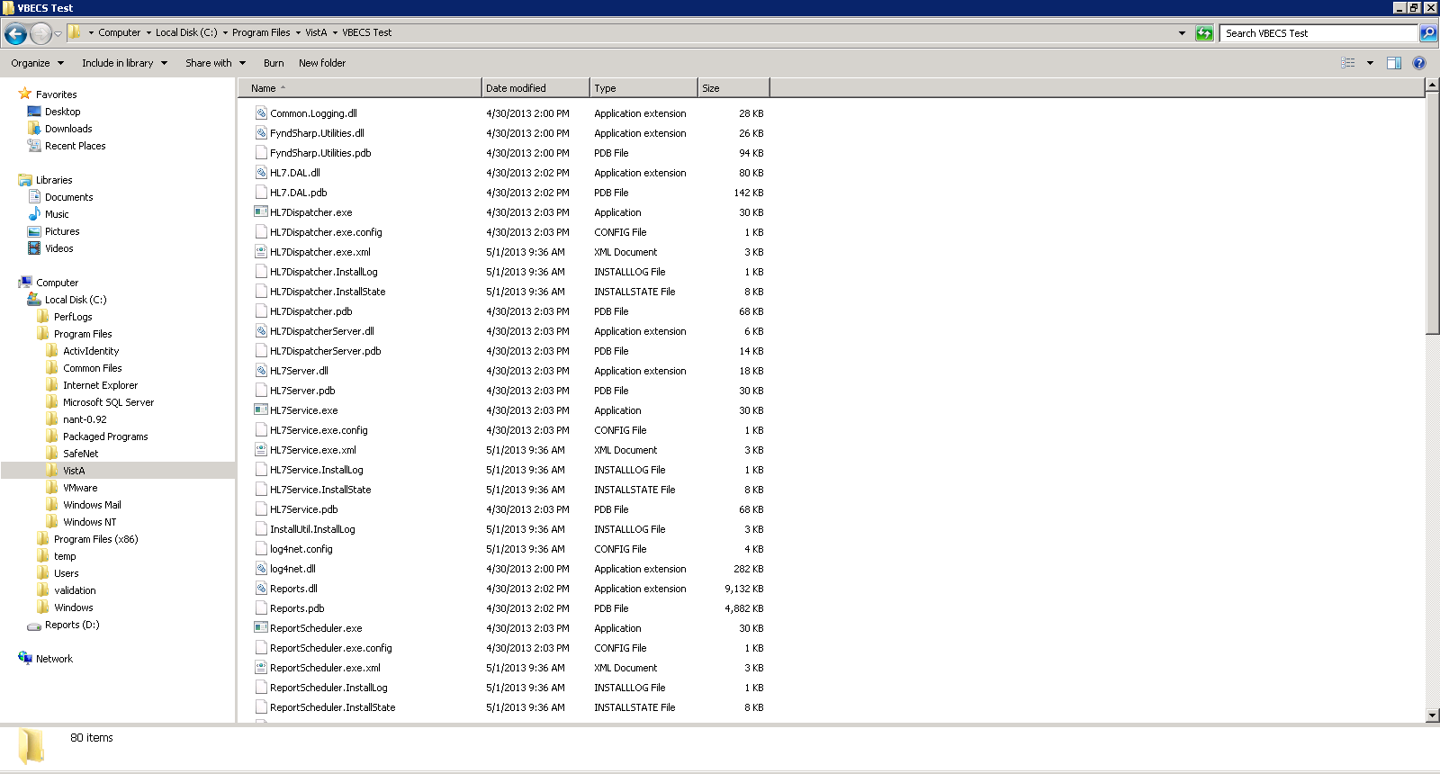
- Open the list of Windows Services (Start, Administrative Tools, Services) and verify that the following four services are listed and that they are listed under aac.dva.domain\VAAACVBESVCPPD user (Figure 5):
- VBECS Test HL7 Dispatcher
- VBECS Test HL7 Listener
- VBECS Test Report Scheduler
- VBECS Test VistALink Listener
Figure 5: Example of Services Screen Showing VBECS Test Services
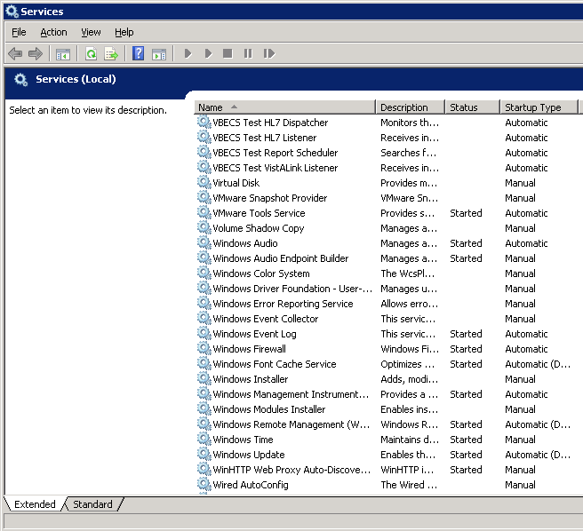
- Using Windows Explorer, navigate to C:\temp\Release Install <build>. Find the Install.log file and rename it to Install_<servername>_<build>_Test_<MMDDYY>.log [substitute <servername> for the name of the application server and <MMDDYY> for the current month, date and year (e.g., Install_VHANDYAPP_2.0.0.3_Test_042213.log)].
- File the log file in VSS Doc/VBECS Design and Device Records/VBECS 2.0.0 Project Documents/Packaging, Labeling, and User Documentation Specifications/Installation Guides/Installation Output.
- Delete the installation log files located in the C:\temp\Release Install <build> folder.

Install VBECS Binaries and Services for the Production Environment
- In the command prompt window, type patch prod install and press Enter.
- Verify that after the installation is complete, BUILD SUCCEEDED is displayed in the command prompt window (Figure 6).
Figure 6: Example of Successful Installation
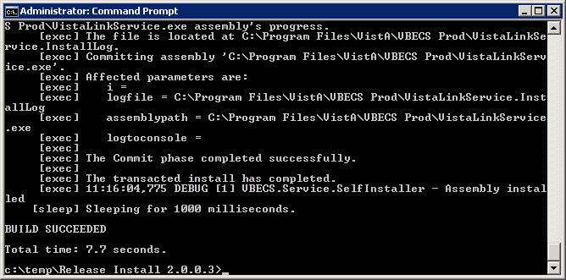
- Using Windows Explorer, navigate to c:\Program Files\VistA and verify that the VBECS Prod directory exists. Open VBECS Prod directory and confirm that it contains VBECS binaries (Figure 7).
Figure 7: Example of c:\Program Files\VistA\VBECS Prod Directory Contents after Successful Installation of VBECS Production Binaries
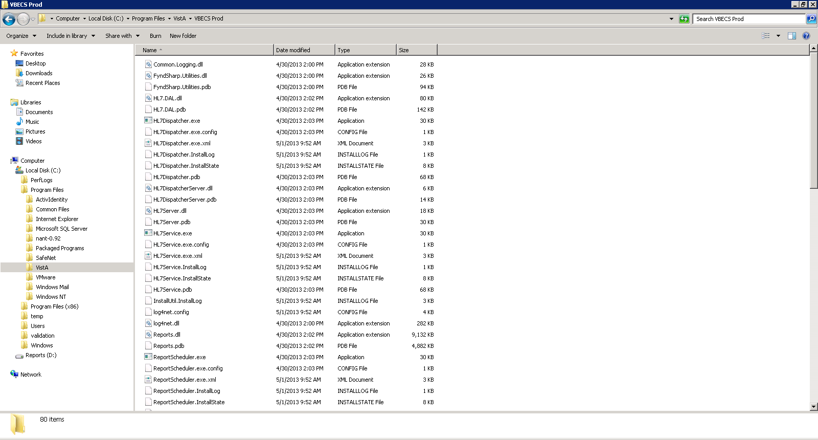
- Open the list of Windows Services (Start, Administrative Tools, Services) and verify that the following four services are listed and that they are listed under server_redacted user (Figure 8):
- VBECS Prod HL7 Dispatcher
- VBECS Prod HL7 Listener
- VBECS Prod Report Scheduler
- VBECS Prod VistALink Listener
- For each VBECS Prod service, right click, click Properties, click the Log On tab, change This account from “server_redacted” to “server_redacted”, supply the password and click OK
Figure 8: Example of Services Screen Showing VBECS Prod Services
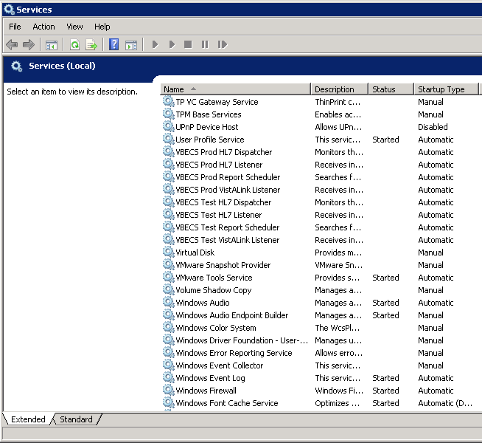
- Using Windows Explorer, navigate to C:\temp\Release Install <build>. Find the Install.log file and rename it to Install_<servername>_<build>_Prod_<MMDDYY>.log [substitute <servername> for the name of the application server and <MMDDYY> for the current month, date and year (e.g., Install_VHANDYAPP_2.0.0.3_Prod_042213.log)].
- File the log file in VSS Doc/VBECS Design and Device Records/VBECS 2.0.0 Project Documents/Packaging, Labeling, and User Documentation Specifications/Installation Guides/Installation Output.
- Delete the installation log files located in the C:\temp\Release Install <build> folder. Empty the recycle bin.

This is the last page of VistA Blood Establishment Computer Software (VBECS) 2.0.0 Installation Guide.

